**Guru Gobind Singh Foundations**

**Guru Gobind Singh Polytechnic Nashik.**

**Entrepreneurship Development (EDE- 22032)**

**Report**

**on**

**Activity**

**Title/Name: Best From Waste**

**Student Name: Sakshi Baviskar**

**Class and Div : TYCO - A**

**Date:**

**----------------------------------------------------------------------------------------------------------**

**Details of activity :**

Best out of waste simply means to make or to bring out something innovative and attractive thing from the material we do not use anymore, which we call waste.

It is a simple process to REUSE, RECYCLE and REDUCE.

**What you learned/skills are developed from this activity :**

Recycling is one of the ways in which we can learn how to conserve resources and reuse them, rather than discard or dispose them and add to our mounds of waste. Recycling helps us to understand our responsibility towards nature and environment. This activity is a way to showcase our innovation skill, creativity and our imagination.

We created a Paper Bag from newspaper.

**Material we required :-**

Newspaper , ID card string , staple.

Using this material we made a newspaper bag. We can use this bag for carrying light weight object.

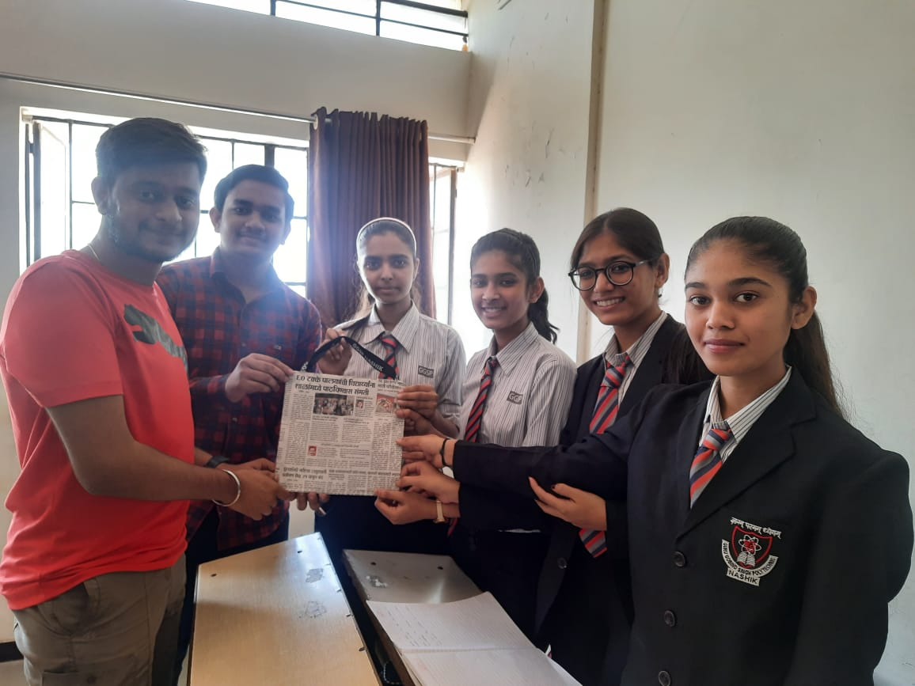

**Subject Teacher**  **Student Sign**

**Guru Gobind Singh Foundations**

**Guru Gobind Singh Polytechnic Nashik.**

**Entrepreneurship Development (EDE- 22032)**

**Report**

**on**

**Activity**

**Title/Name: Flip the classroom**

**Student Name: Sakshi Baviskar**

**Class and Div : TYCO - A**

**Date:**

**----------------------------------------------------------------------------------------------------------**

**Details of activity :**

We formed 2 teams - Team 1 and Team 2. From each team 3 members were taken. Then 2 groups were made from those 6 members, each group containing 2 members from same team and 1 member from opposite team. The opposite team member had to hid the ball and then the members from same team has to find the ball. The one who hid the ball would tell direction using Left and Right sign only by facing the wall. One member from same team would dictate the action to another member and that member would search for the hidden ball as the 1st member dictated.

**What you learned/skills are developed from this activity :**

From this activity, we learned the importance of communication and co-ordination between team members. Lack of communication and co-ordination can crate problems or mess up the work.

Good teamwork ,communication and direction leads you to achieve your goal.

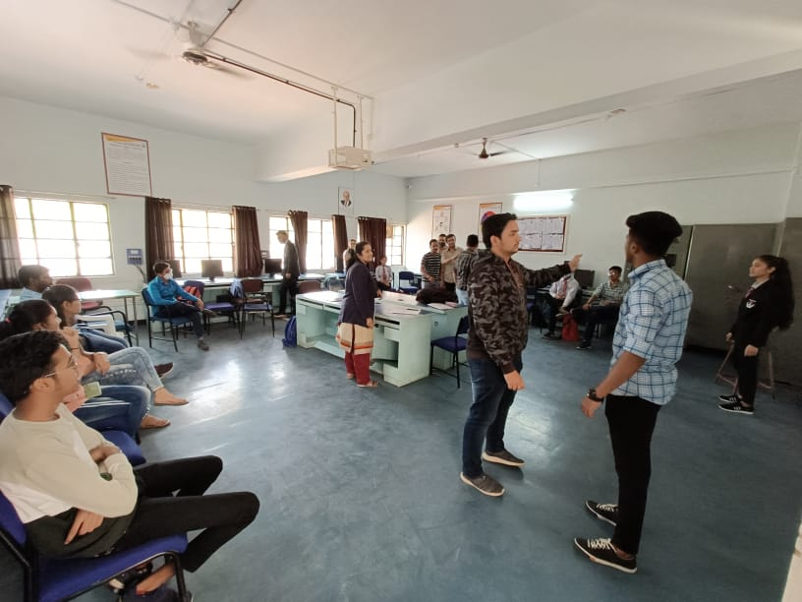

**Subject Teacher**  **Student Sign**

**Guru Gobind Singh Foundations**

**Guru Gobind Singh Polytechnic Nashik.**

**Entrepreneurship Development (EDE- 22032)**

**Report**

**on**

**Activity**

**Title/Name: Skeleton activity**

**Student Name: Sakshi Baviskar**

**Class and Div : TYCO - A**

**Date:**

**----------------------------------------------------------------------------------------------------------**

**Details of activity :**

In this activity, we divided class into 5 teams and each team was given a sketch of skeleton. We had relate body parts with skills that need to become successful entrepreneur or to run a successful company. Our team number was 5.

**What you learned/skills are developed from this activity :**

From this activity we learned that just like our body parts co-ordinate with each other and work as team to perform a task successfully, it is important to work as a team in a company or in a startup.

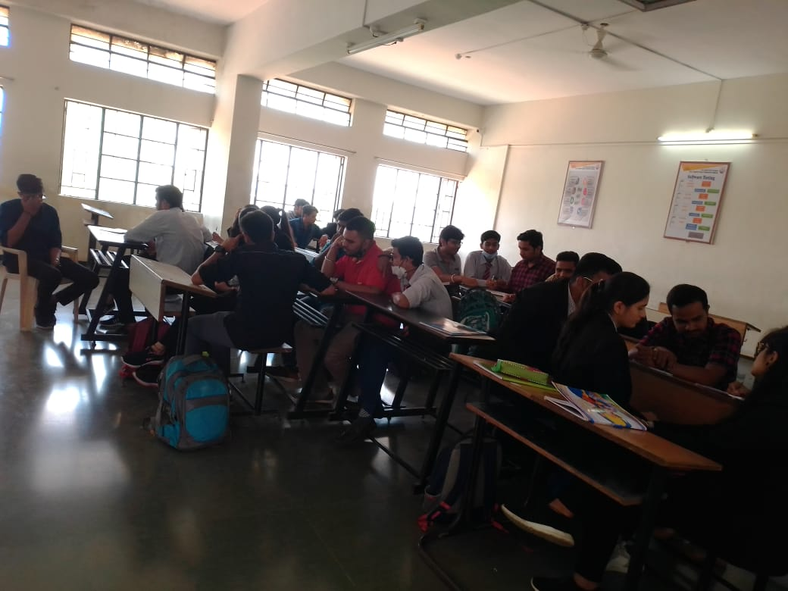

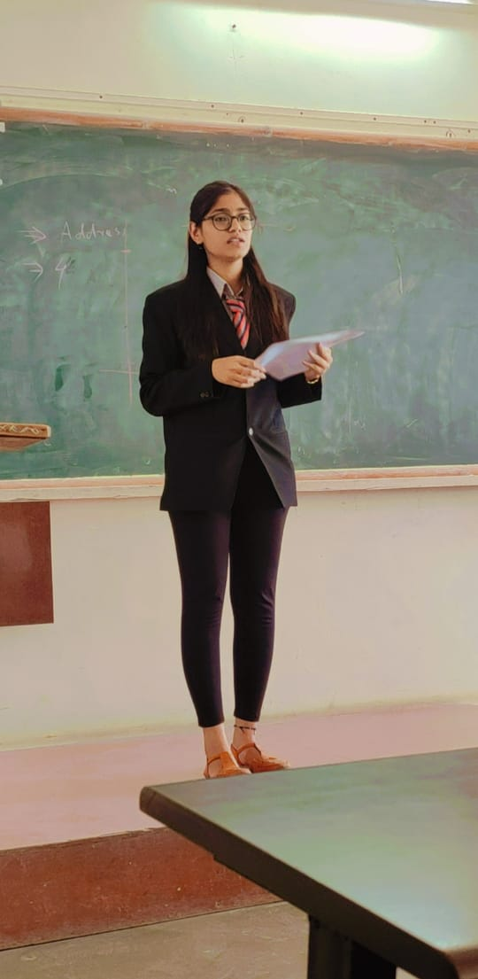 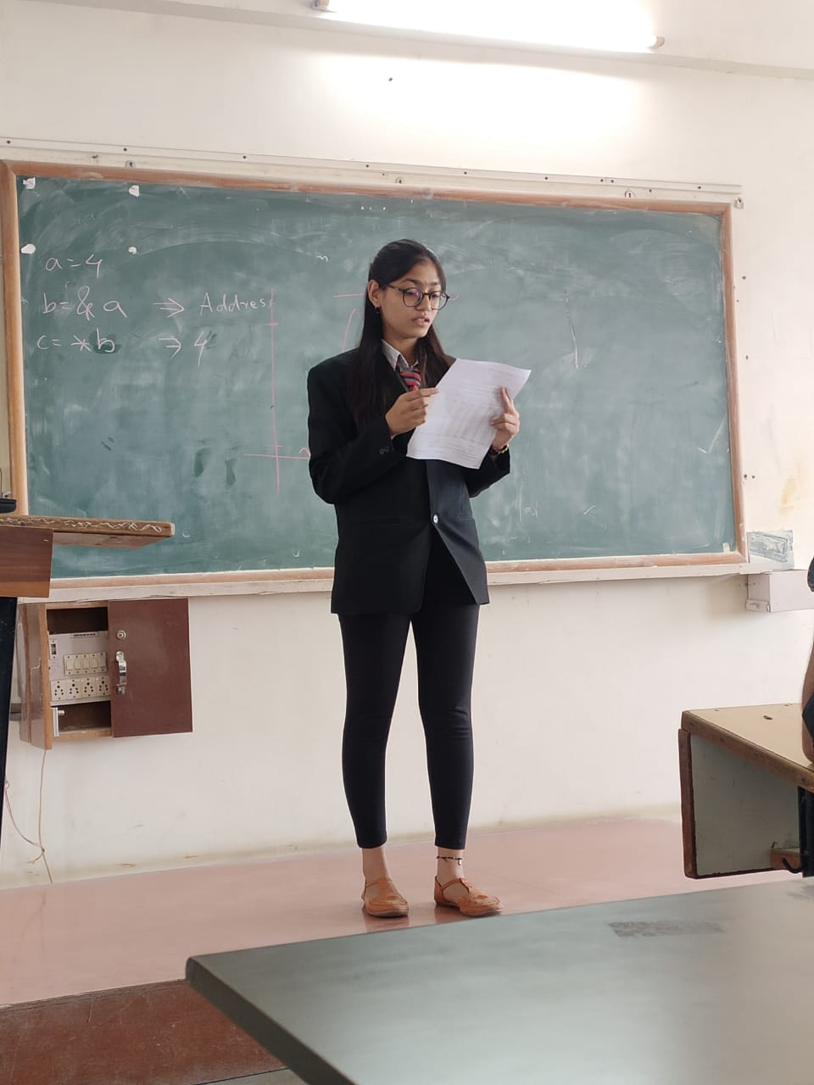

**Team number - 5**

**Team Members :**

1. Sakshi Baviskar (Roll no. - 33) (Team leader)
2. Pranali Nere (Roll no. - 10)
3. Samruddhi Bhamre (Roll no. - 45)
4. Shubham Mahajan (Roll no. - 48)
5. Venkatesh Sonar (Roll no. - 90)

**Subject Teacher**  **Student Sign**